**Microsoft Exel Assignment 6**

1. **What are the various elements of the Excel interface? Describe how they're used.**

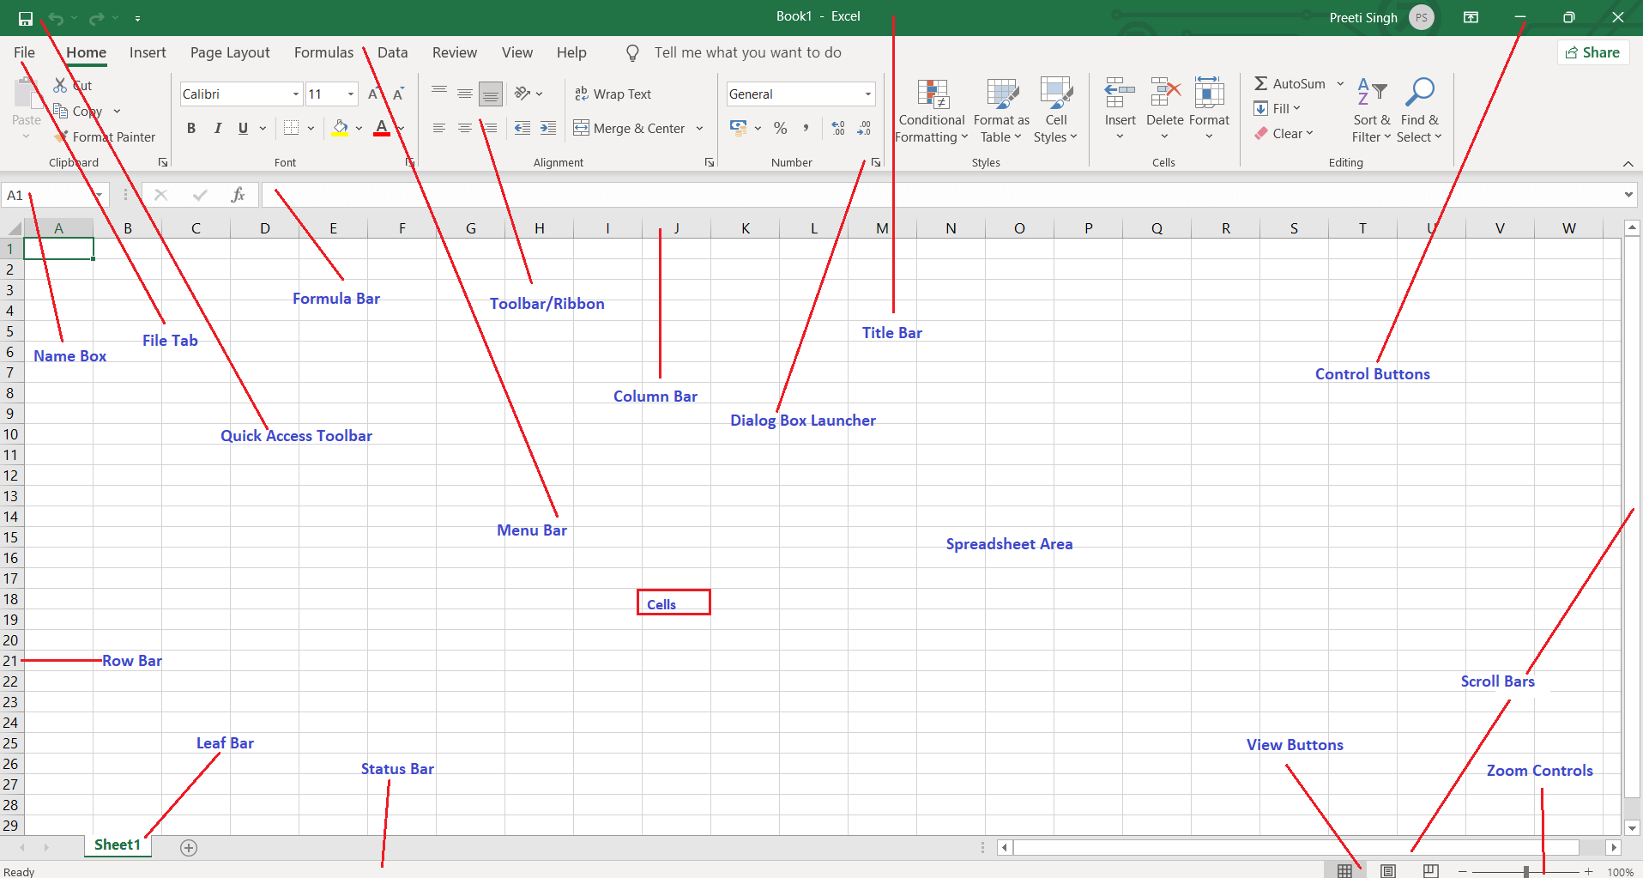

The following are the basic parts of the Microsoft Excel Window:

* Quick Access Toolbar
* File Tab
* Title Bar
* Control Buttons
* Menu Bar
* Ribbon/Toolbar
* Dialog Box Launcher
* Name Box
* Formula Bar
* Scroll Bars
* Spreadsheet Area
* Leaf Bar
* Column Bar
* Row Bar Cells
* Cells
* Status Bar
* View Buttons
* Zoom control

1. **Write down the various applications of Excel in the industry.**

* Data entry
* Data management
* Accounting
* Financial analysis
* Charting and graphing
* Programming
* Time management
* Task management
* Financial modeling
* Customer relationship management (CRM)
* Almost anything that needs to be organized

1. **On the ribbon, make a new tab. Add some different groups, insert**

**commands in the groups and name them according to their commands**

**added. Copy and paste the screenshot of the steps you followed.**

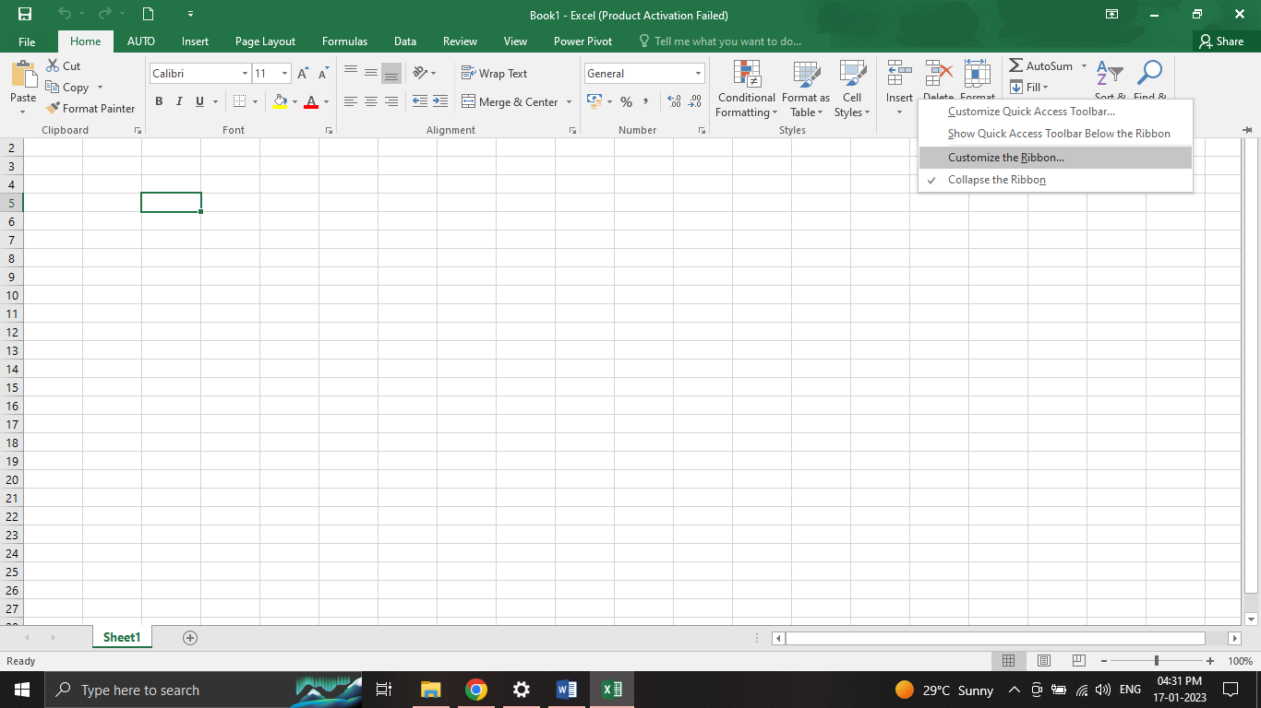

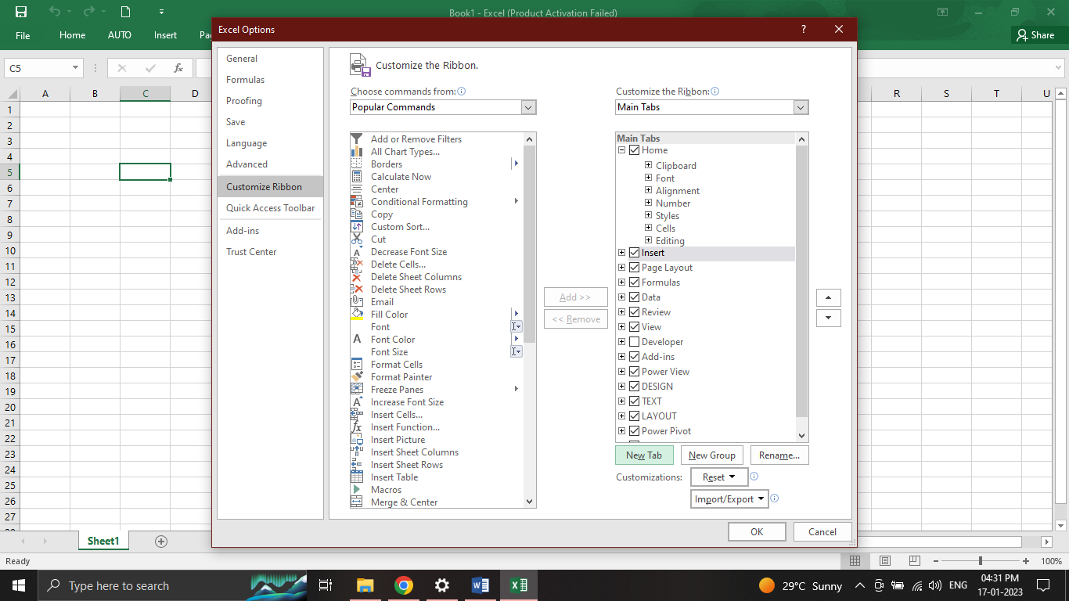

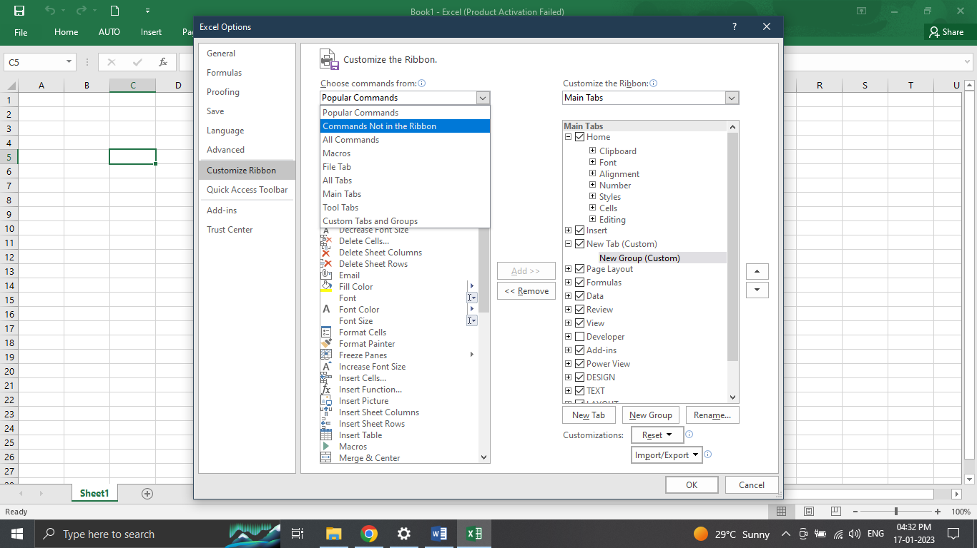

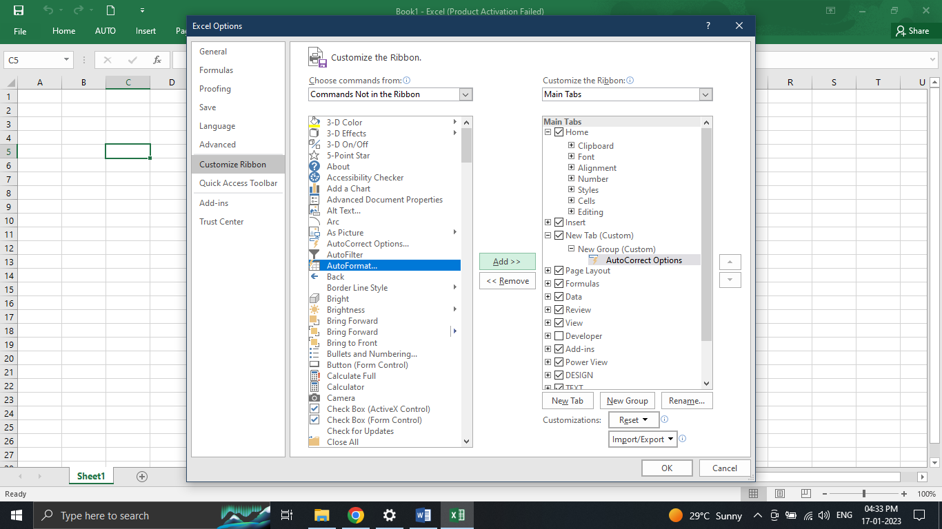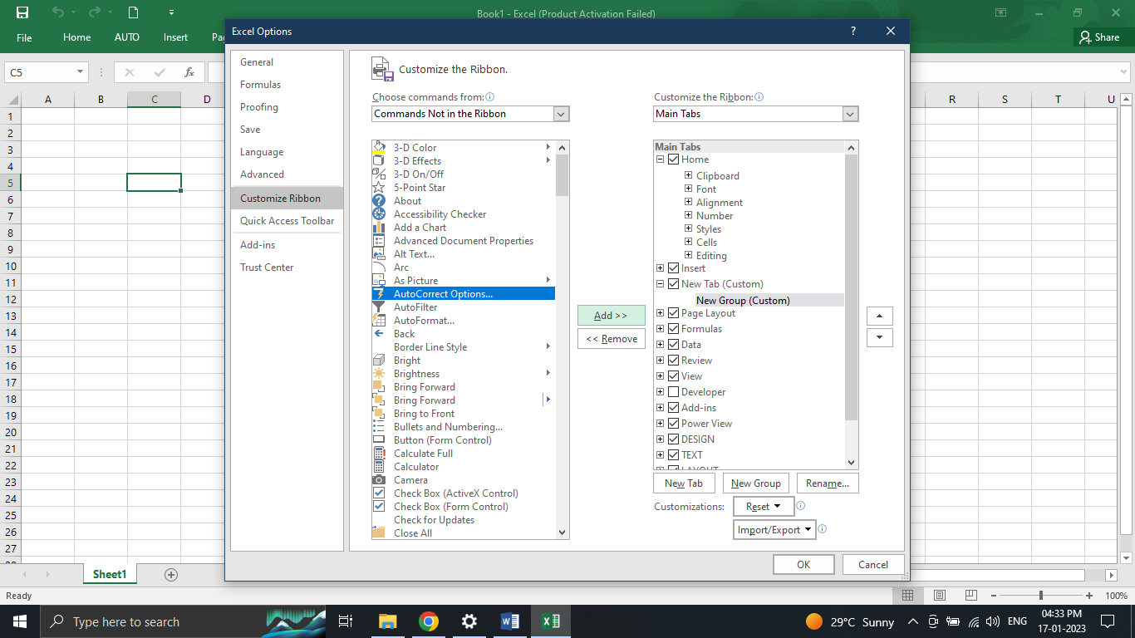

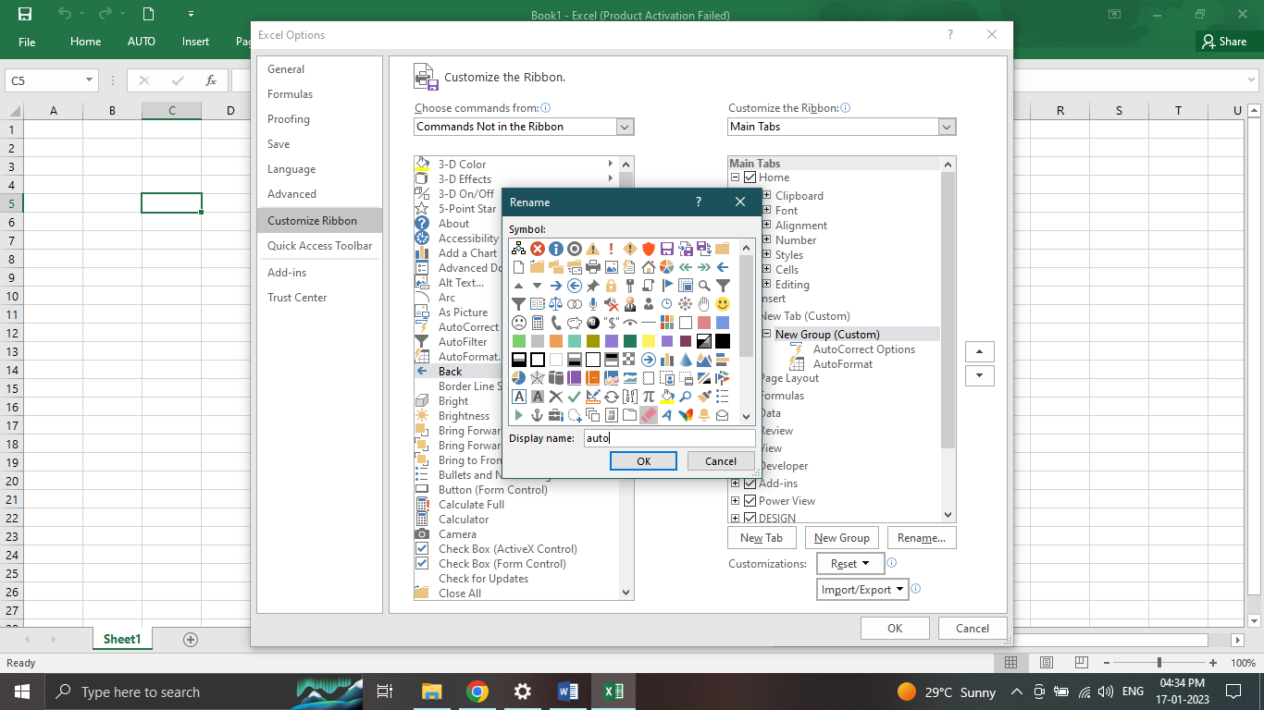

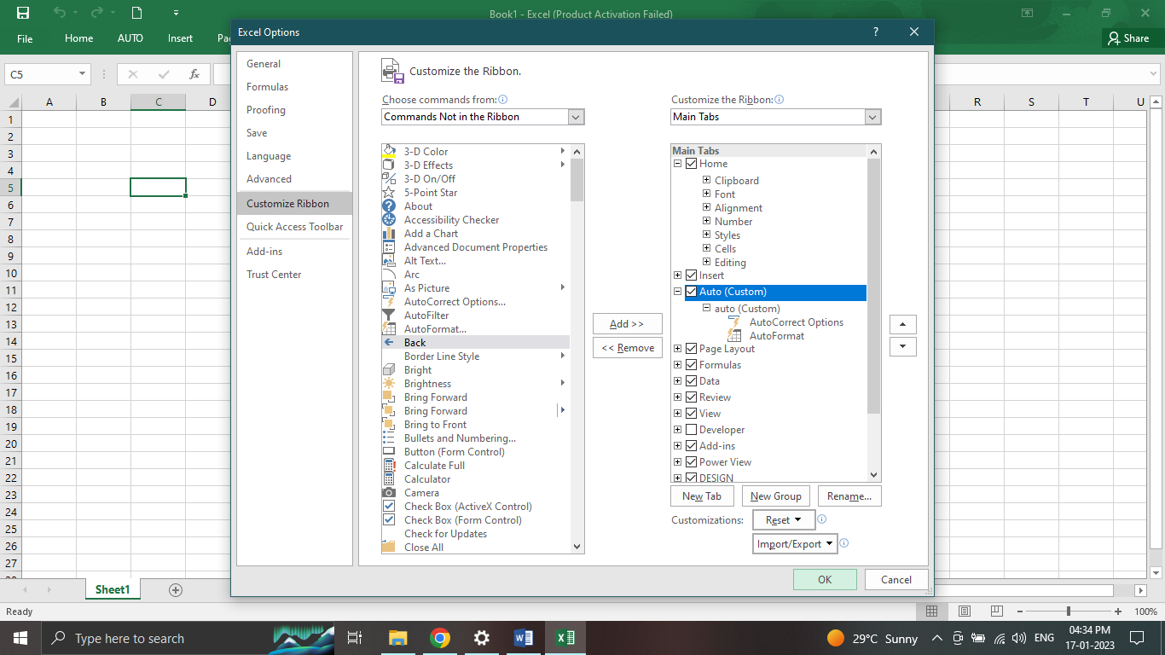

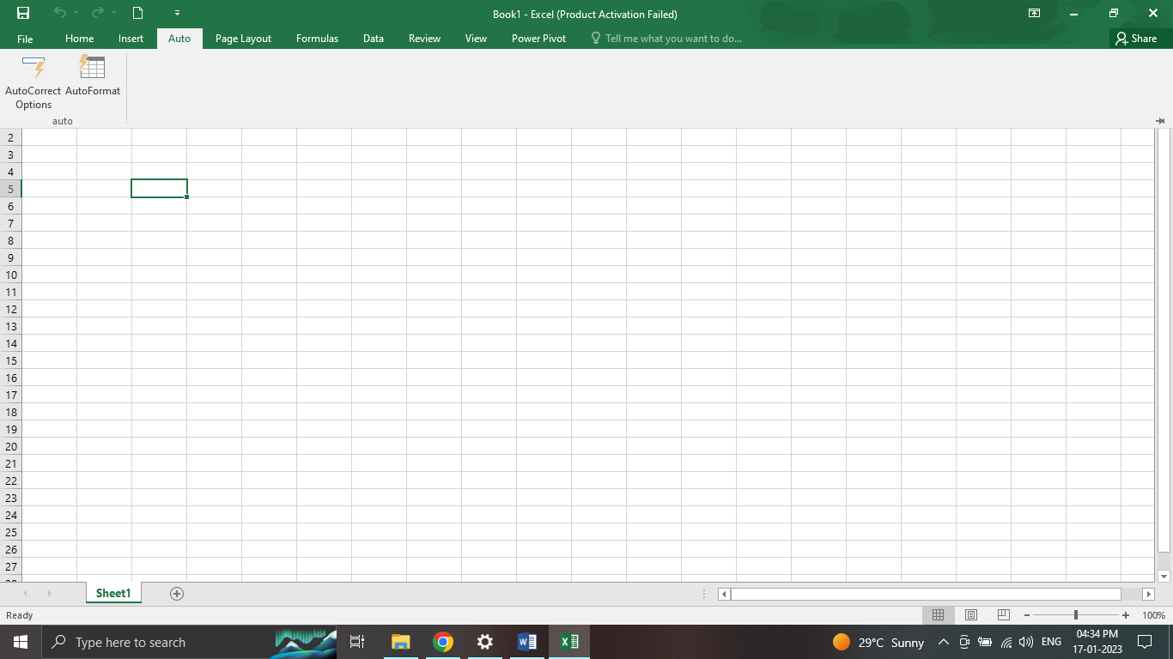

1. **Make a list of different shortcut keys that are only connected to formatting with their functions.**

This table shows the most frequently used shortcuts in Microsoft Word.

| To do this | Press |
| --- | --- |
| Open a document. | Ctrl+O |
| Create a new document. | Ctrl+N |
| Save the document. | Ctrl+S |
| Close the document. | Ctrl+W |
| Cut the selected content to the Clipboard. | Ctrl+X |
| Copy the selected content to the Clipboard. | Ctrl+C |
| Paste the contents of the Clipboard. | Ctrl+V |
| Select all document content. | Ctrl+A |
| Apply bold formatting to text. | Ctrl+B |
| Apply italic formatting to text. | Ctrl+I |
| Apply underline formatting to text. | Ctrl+U |
| Decrease the font size by 1 point. | Ctrl+Left bracket ([) |
| Increase the font size by 1 point. | Ctrl+Right bracket (]) |
| Center the text. | Ctrl+E |
| Align the text to the left. | Ctrl+L |
| Align the text to the right. | Ctrl+R |
| Cancel a command. | Esc |
| Undo the previous action. | Ctrl+Z |
| Redo the previous action, if possible. | Ctrl+Y |
| Adjust the zoom magnification. | Alt+W, Q, then use the Tab key in the **Zoom** dialog box to go to the value you want. |
| Split the document window. | Ctrl+Alt+S |
| Remove the document window split. | Alt+Shift+C or Ctrl+Alt+S |
|  |  |
|  |  |
|  |  |

1. **What distinguishes Excel from other analytical tools?**

Excel will use range of formulas to unlock the potential of data. You have to insert data in individual cells of columns and rows. In this way, data will be filtered and sorted and hence displayed in a presentable manner

**6. Create a table and add a custom header and footer to your table.**

